**LAB TASK**

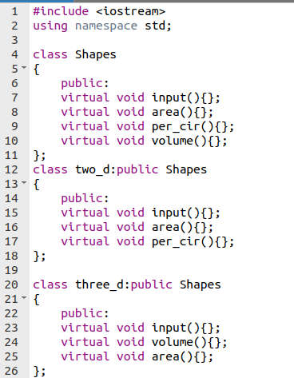

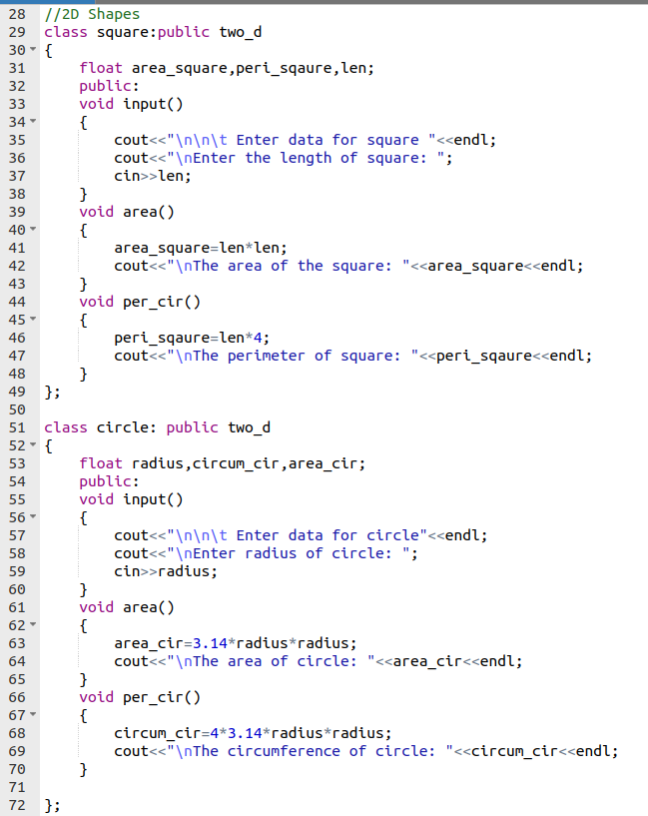

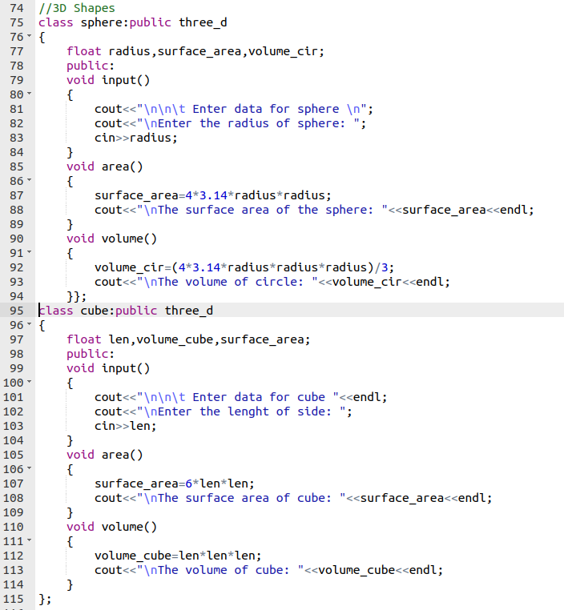

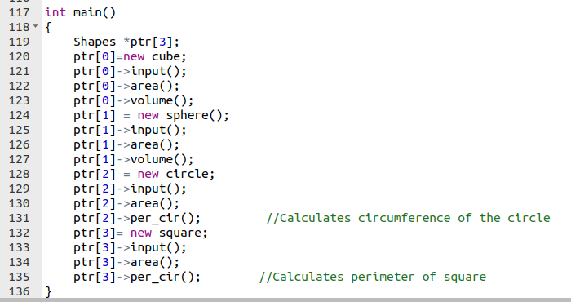

**OUTPUT**

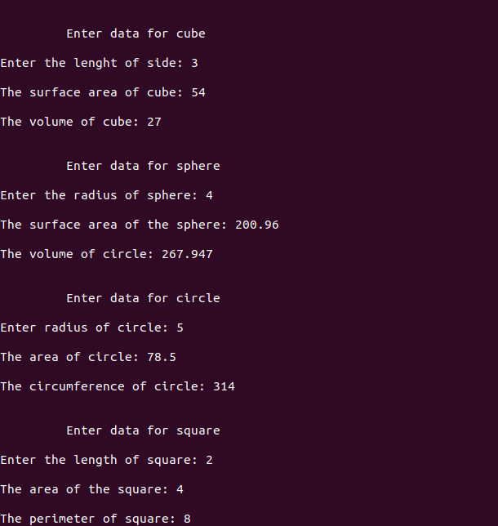

**Conclusion:**

In this lab learned how to solve a mathematical problem using the techniques of polymorphism and inheritance. I also revised how to use pointers in polymorphism.